Quotation for fermentation machine
Project Name：
Maker：
Contact person：
Wechat/Whatsapp/Phone：
E-mail：
Date：
Validity：
1
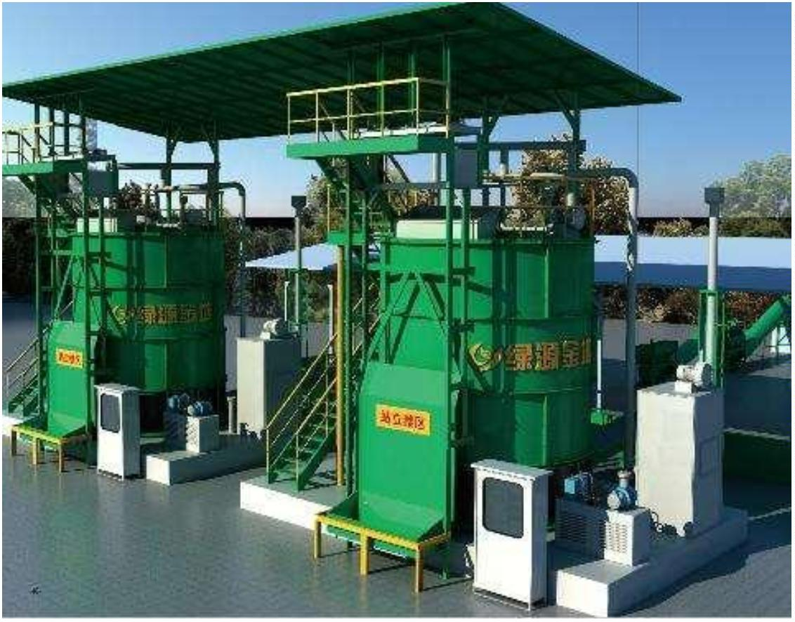

Part one ：Price list
1. 11FFG-40 type
Price list
No
Product name
Unit price (USD)
Quantity
price (USD)
1
2
3
4
5
Fermentation body
Material lifting device
Ladder
120000
1set
120000
2250
Deodorizing device
PVC /PP pipes
6
7
Port Fee(QINGDAO)
Total price
750
40"HC:3pcs
Product data
Product Model
Volume
11FFG-40
About 40m³
4500mm
Diameter
Tank height
Ceiling height
Weight
4500mm
7700mm
About 15 tons
Installed power
15.7kw (Including auxiliary heating equipment)
Fermentation machine list 11FFG-40
Part
Name
Outside wall material and
thickness
Specifications
Manufacturer
Q235,4.5mm
Green World
Internal bottom plate
material and thickness
Internal roof plate material
and thickness
SUS304, 2mm
SUS304 1.5mm
Green World
Green World
Green World
Tank
body
Thermal insulation material
and thickness
Polyurethane ≥60mm
2
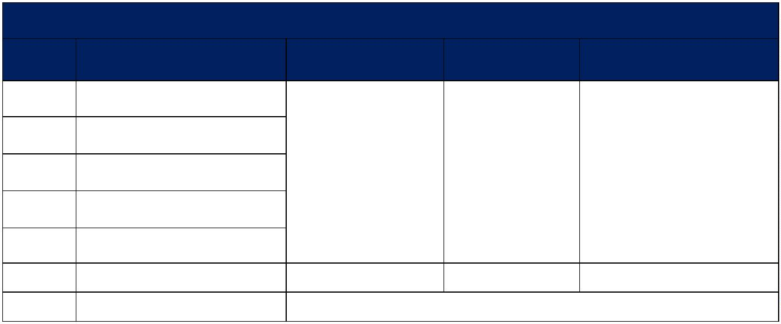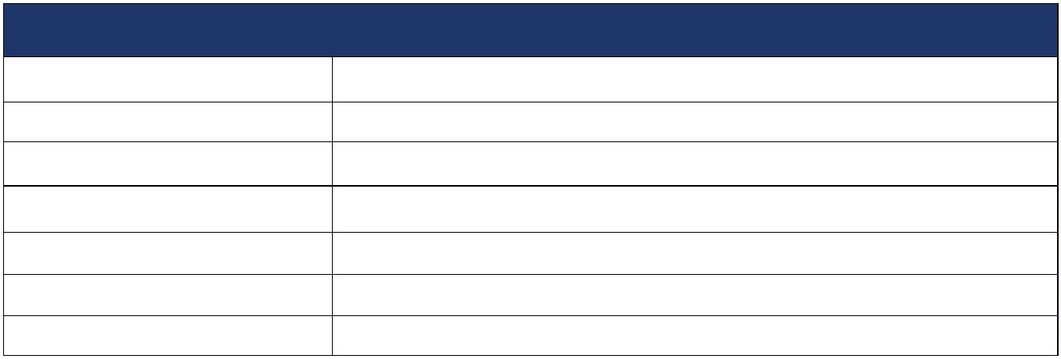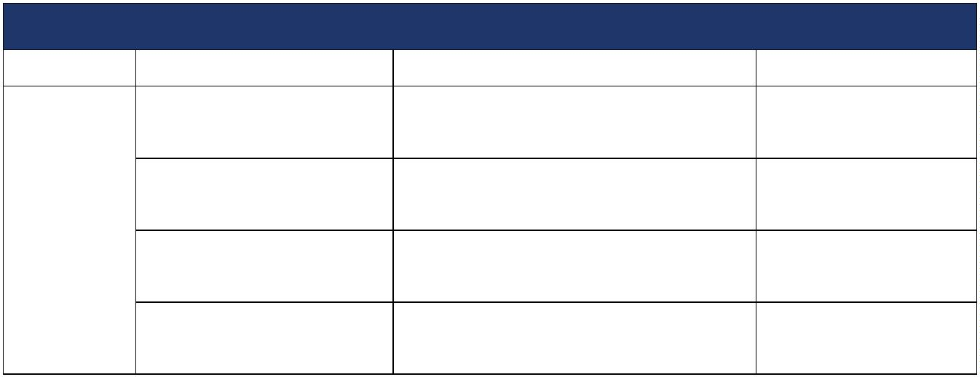

Except the main bone, the other parts in
Stirring blades
Bucket motor
Green World
contact with material are SUS304
2.2KW
Taiwan CPG
Green World
Lifting
device
Lifting bucket material and
thickness
Internal plate SUS304 1.5mm
Exhaust fan
Upper blower
Bottom blower
Hydraulic station
Cast aluminum
High pressure
Siemens motor
HITACHI JAPAN
HITACHI JAPAN
Green World
Ventilation
system
High pressure
motor Siemens Bader
American PARKER or German
TRELLEBORG
Hydraulic cylinder seal ring
World famous Brand
Hydraulic
system
Hydraulic pump
Pin rotation
Japan Daikin
Japan Brand
Green World
Graphite copper sleeve
Main shaft sealing ring
Lubricating
Imported from Japan
Imported from Japan
Green World
Automatic centralized lubrication
Double door waterproof，380V,50Hz
Electrical control box
Green World
Control
system
Electrical elements
Schneider, Omron,PLC Siemens
World famous Brand
Limit switch
Exhaust pipe
Omron
PVC/PP
Omron
Green World
Green World
Green World
Deodoriz
ing
device
Deodorization process
Deodorization tank material
Water washing + adsorption
SUS304
3
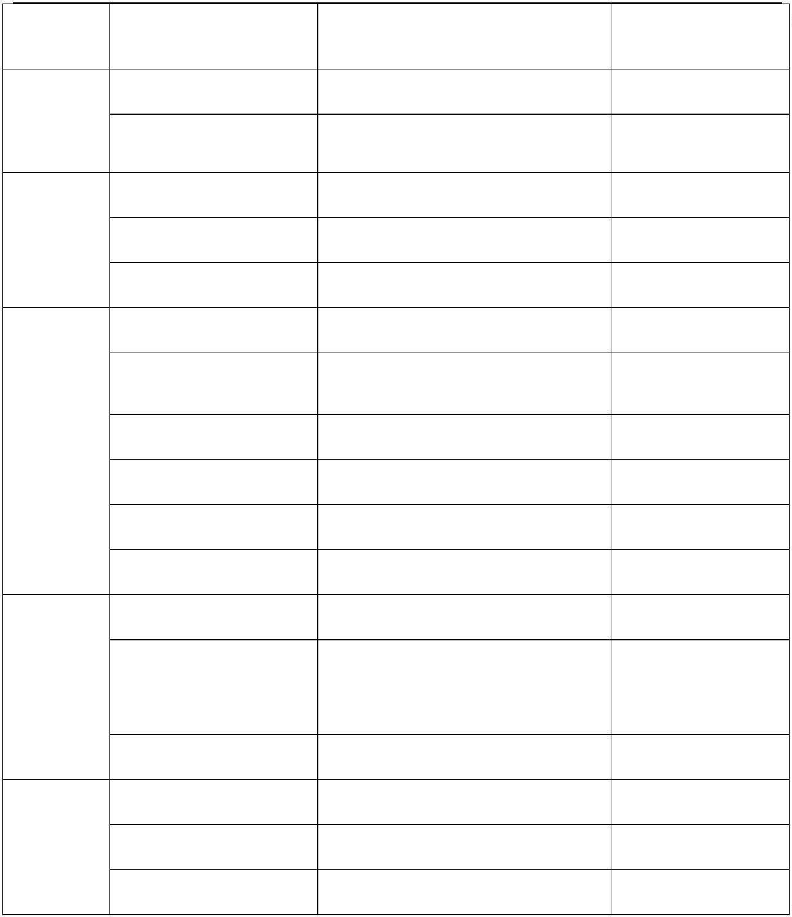

2. 11FFG-60 Type
Price list
No
Product name
Unit price(USD)
Quantity
1set
price (USD)
145000
1
2
3
4
5
Fermentation body
Lifting device
Ladder
145000
Deodorizing device
PVC /PP pipes
3
pieces
0"HC
6
7
Port Fee (Qingdao)
Total price
750
2250
4
Product data
Product Model
11FFG-60
About 60m³
4500mm
5500mm
8700mm
18 tons
Volume
Diameter
Tank height
Ceiling height
Weight
Installed power
22.9 kw (Including auxiliary heating equipment)
Fermentation machinelist-11FFG-60
Part
Name
Outside wall material and
thickness
Specifications
Manufacturer
Q235,4.5mm
Green World
Internal bottom plate
material and thickness
Internal roof plate material
and thickness
SUS304, 2mm
SUS304 1.5mm
Green World
Green World
Green World
Tank
body
Thermal insulation material
and thickness
Polyurethane ≥60mm
4
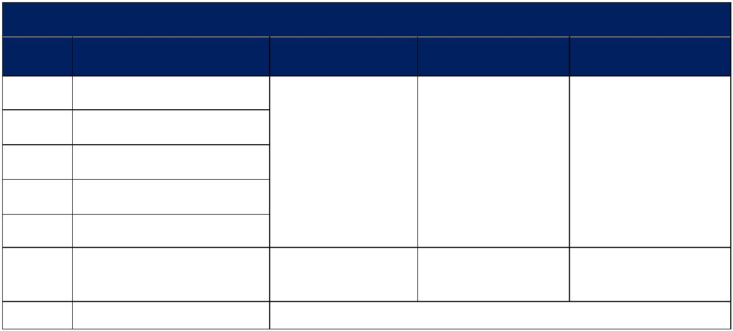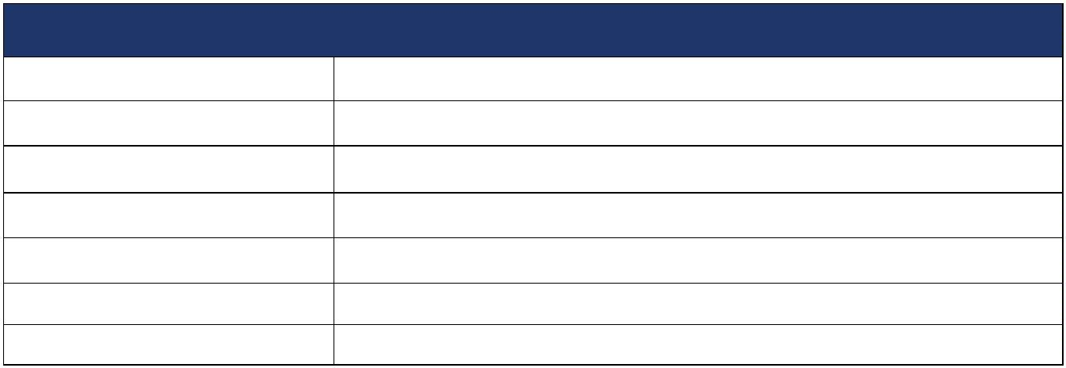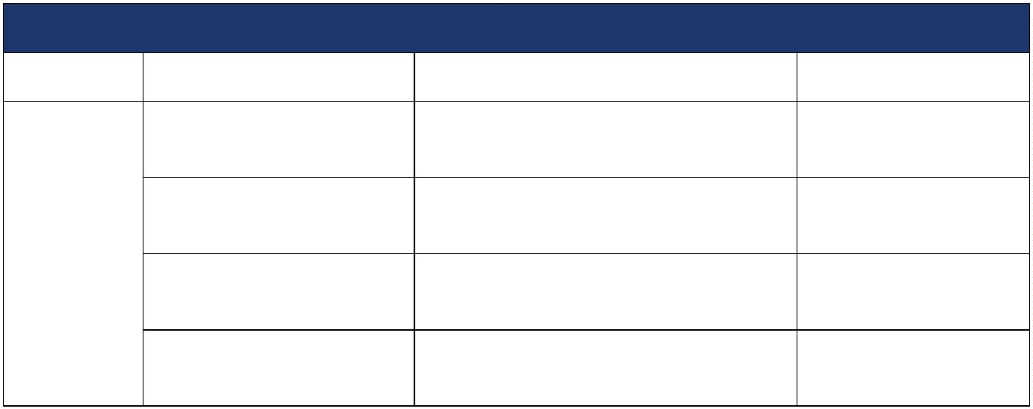

Except the main bone, the other parts in
Stirring blades
Bucket motor
Green World
contact with material are SUS304
2.2KW
Taiwan CPG
Green World
Lifting
bucket
Bucket material and
thickness
Internal surface SUS304 1.5mm
Exhaust fan
Upper blower
Bottom blower
Hydraulic station
Cast aluminum
Siemens motor
HITACHI JAPAN
HITACHI JAPAN
Green World
Ventilati
on
system
High pressure blower
High pressure blower
motor：Siemens Bader
American PARKER or German
TRELLEBORG
Hydraulic cylinder seal ring
World famous Brand
Drive
system
Hydraulic pump
Pin rotation
DAKIN
Japan Brand
Green World
Graphite copper sleeve
Shaft sealing ring
Lubricating
Imported from Japan
Imported from Japan
Green World
Automatic centralized lubrication
Double door waterproof，380V,50Hz
Electrical control box
Green World
Control
system
Electrical elements
Schneider, Omron，PLC Siemens
World famous Brand
Limit switch
Exhaust pipe
Omron
PVC/PP
Omron
Green World
Green World
Green World
Deodorizin
g device
Deodorization process
Deodorization tank material
Water washing + adsorption
SUS304
5

3. 11FFG-90 Type
Price list
No
Product name
Unit price(USD)
Quantity
price (USD)
1
2
3
4
5
Fermentation body
Material lifting device
Ladder
1
80000
1set
180000
Deodorizing device
PVC /PP pipes
4
pieces
0"HC
6
7
Port Fee (Qingdao)
Total price
750
3000
4
Product data
Product Model
Volume
11FFG-90
About 90m³
5500mm
Diameter
Tank height
Ceiling height
Weight
5500mm
8700mm
About 28 tons
Installed power
38.1kw((Including auxiliary heating equipment)
)
Fermentation machinelist-11FFG-90
Part
Name
Specifications
Manufacturer
Outside wall material and
thickness
Q235,4.5mm
Green World
Internal bottom plate
material and thickness
Internal roof plate material
and thickness
SUS304, 2mm
SUS304 1.5mm
Green World
Green World
Green World
Tank
body
Thermal insulation material
and thickness
Polyurethane ≥60mm
Except the main bone, the other parts in
contact with material are SUS304
Stirring blades
Bucket motor
Green World
Taiwan CPG
Lifting
2.2KW
6
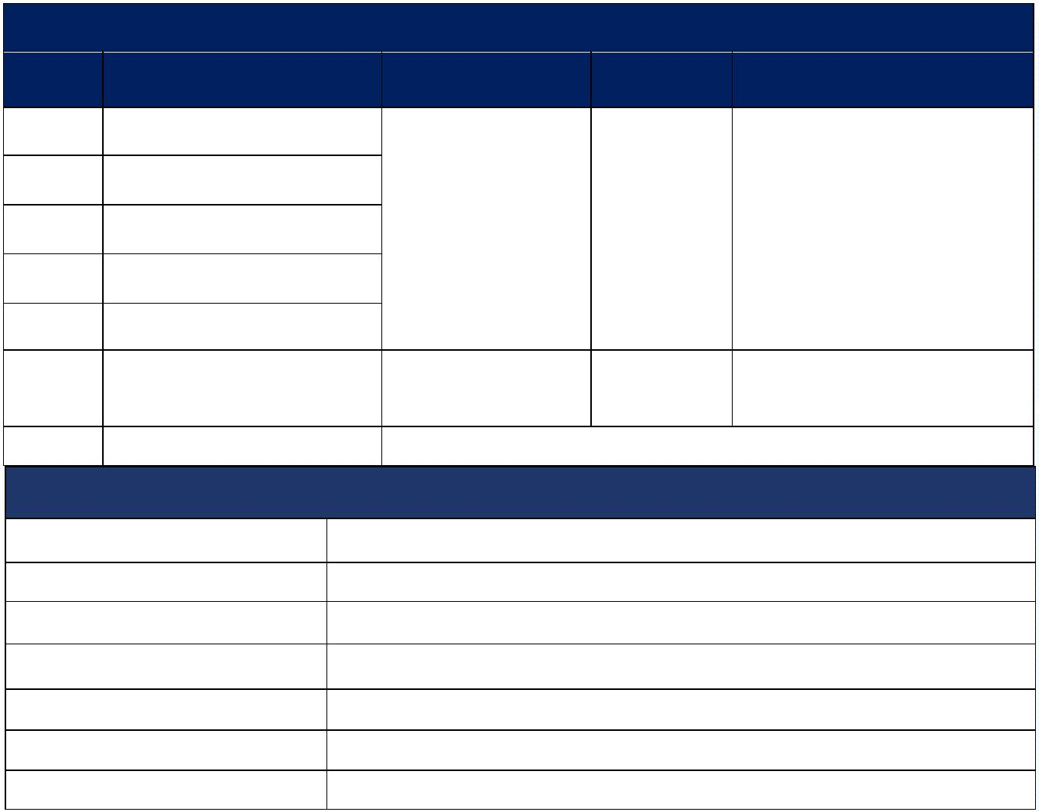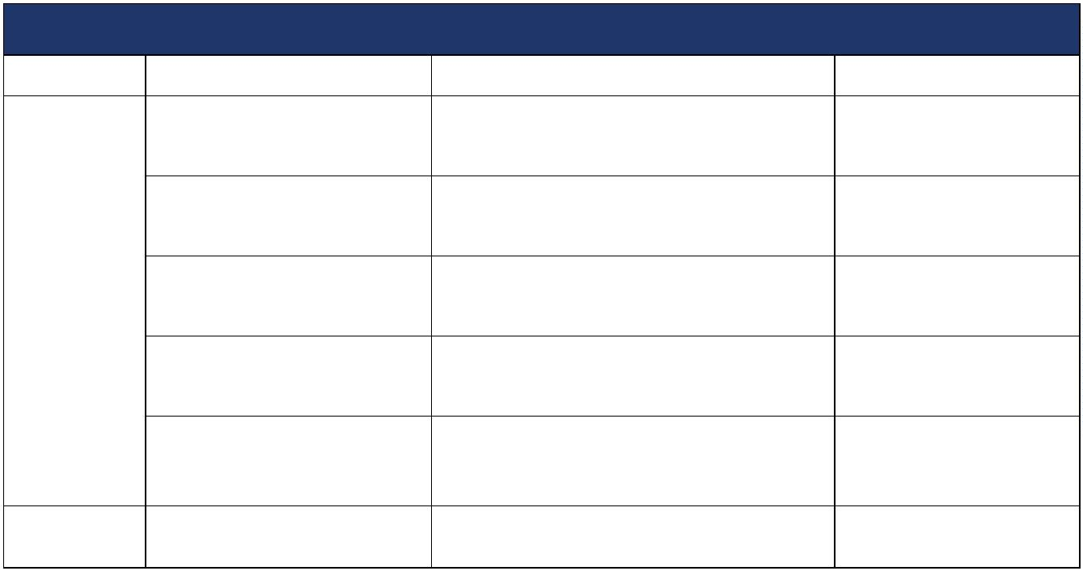

bucket
bucket material and
thickness
Internal bucket surface SUS304 1.5mm
Green World
Exhaust fan
Upper blower
Bottom blower
Hydraulic station
Cast aluminum
Siemens motor
HITACHI JAPAN
HITACHI JAPAN
Green World
Ventilati
on
system
High pressure blower
High pressure blower
motor：Siemens Bader
American PARKER or German
TRELLEBORG
Hydraulic cylinder seal ring
World famous Brand
Drive
system
Hydraulic pump
Pin rotation
Japan Daikin
Japan Brand
Green World
Graphite copper sleeve
Shaft sealing ring
Lubricating
Imported from Japan
Imported from Japan
Green World
Automatic centralized lubrication
Double door waterproof，380V,50Hz
Electrical control box
Green World
Control
system
Electrical elements
Schneider, Omron，PLC Siemens
World famous Brand
Limit switch
Exhaust pipe
Omron
PVC/PP
Omron
Green World
Green World
Green World
Deodoriz
ing
device
Deodorization process
Deodorization tank material
Water washing + adsorption
SUS304
7
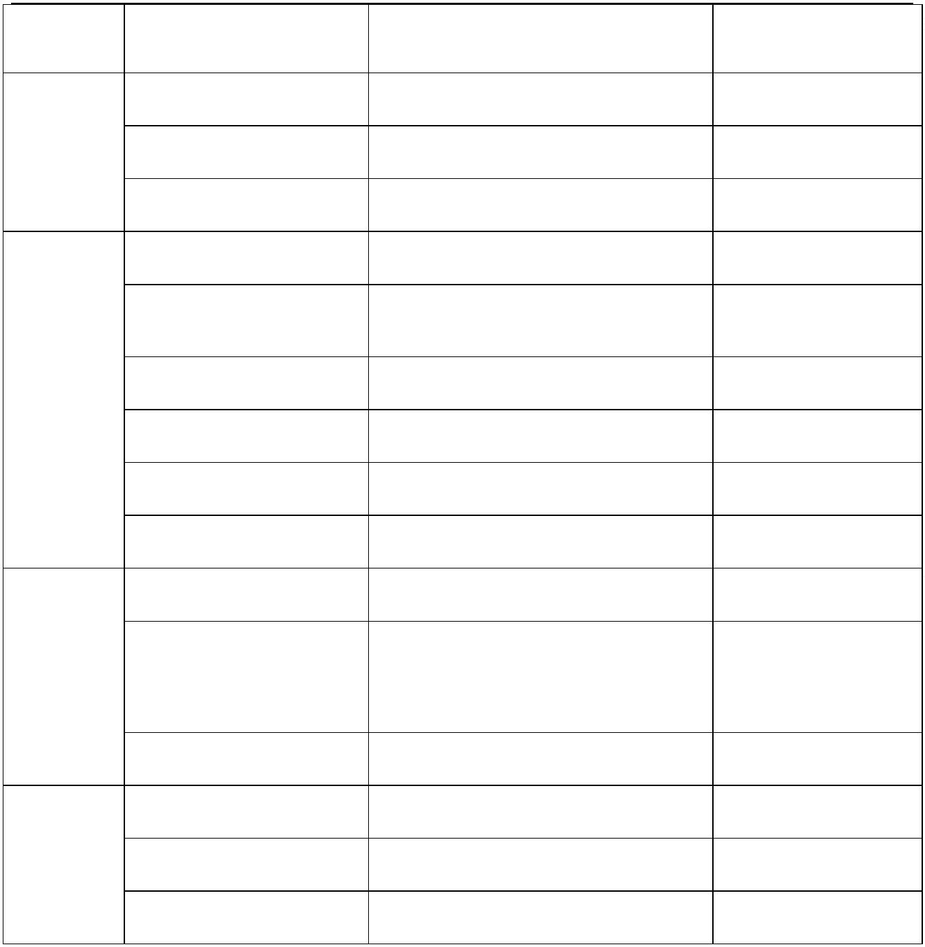

4. 11FFG-110 Type
Price list
No
Product name
Unit price(USD)
Quantity
price (USD)
1
2
3
4
5
Fermentation body
Material lifting device
Ladder
195000
1set
195000
Deodorizing device
PVC /PP pipes
4
pieces
0"HC
6
7
Port Fee (Qingdao)
Total price
750
3000
4
Product data
Product Model
Tank volume
Tank diameter
11FFG-110
About 110m³
6000mm
Tank height
Ceiling height
Weight
5500mm
8700mm
About 34 tons
Installed power
38.4kw(Including auxiliary heating equipment)
Fermentation machine configuration-110model
Part
Name
Outside wall material and
thickness
Specifications
Manufacturer
Q235,4.5mm
Green World
Internal bottom plate
material and thickness
Internal roof plate material
and thickness
SUS304, 2mm
SUS304 1.5mm
Green World
Green World
Green World
Tank
body
Thermal insulation material
and thickness
Polyurethane ≥60mm
8
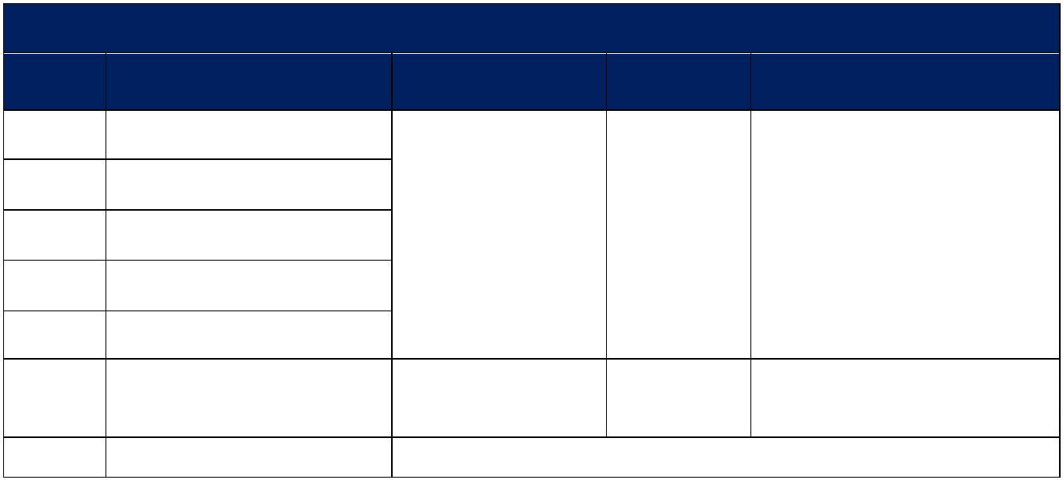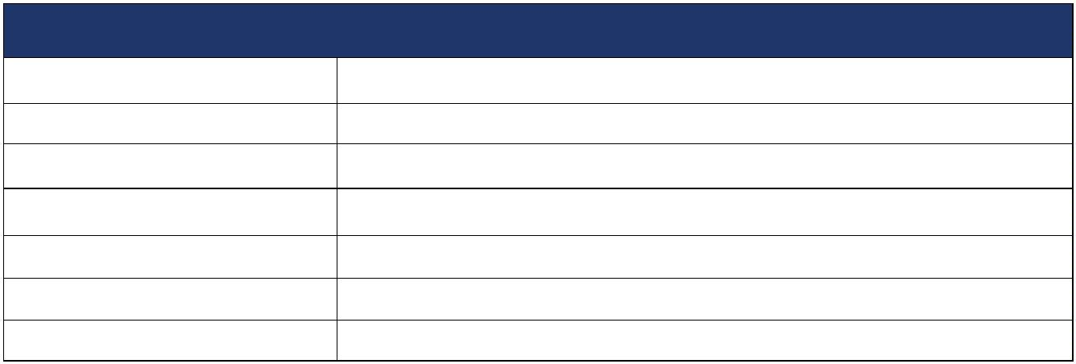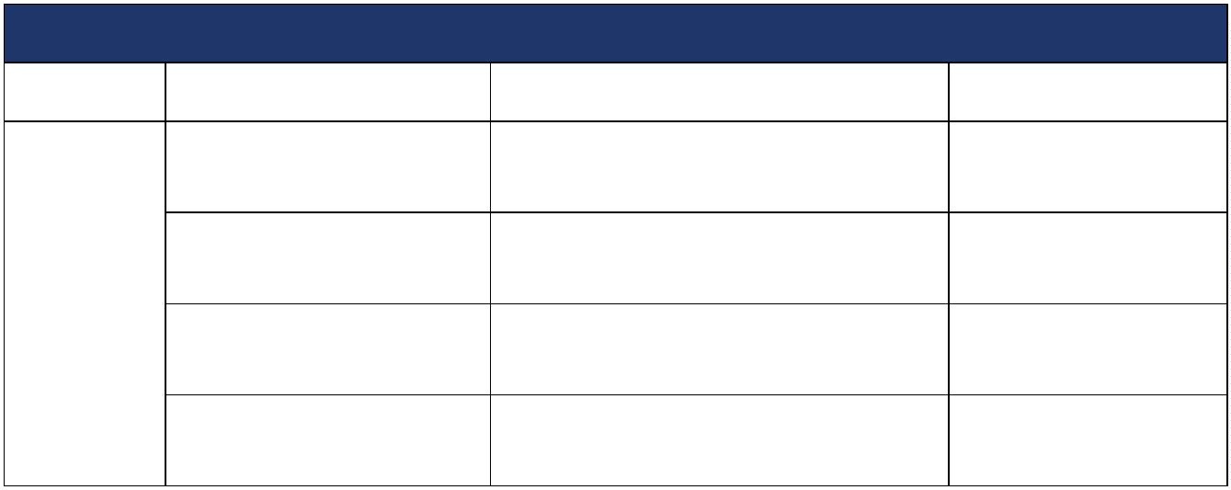

Except the main bone, the other parts in
Stirring blades
Bucket motor
Green World
contact with material are SUS304
2.2KW
Taiwan CPG
Green World
Lifting
bucket
Lifting bucket material and
thickness
Internal plate SUS304 1.5mm
Exhaust fan
Upper blower
Cast aluminum
Siemens motor
HITACHI JAPAN
HITACHI JAPAN
Green World
Ventilati
on
system
High pressure blower
High pressure blower
motor：Siemens Bader
Bottom blower
Hydraulic station power
American PARKER or German
TRELLEBORG
Hydraulic cylinder seal ring
World famous Brand
Drive
system
Hydraulic pump
Pin rotation
Japan Daikin
Japan Brand
Green World
Graphite copper sleeve
Shaft sealing ring
Lubricating
Imported from Japan
Imported from Japan
Green World
Automatic centralized lubrication
Double door waterproof，380V,50Hz
Electrical box
Green World
Control
system
Electrical elements
Schneider, Omron，PLC Siemens
World famous Brand
Limit switch
Exhaust pipe
Omron
PVC/PP
Omron
Green World
Green World
Green World
Deodoriz
ing
device
Deodorization process
Deodorization tank material
Water washing + adsorption
SUS304
9
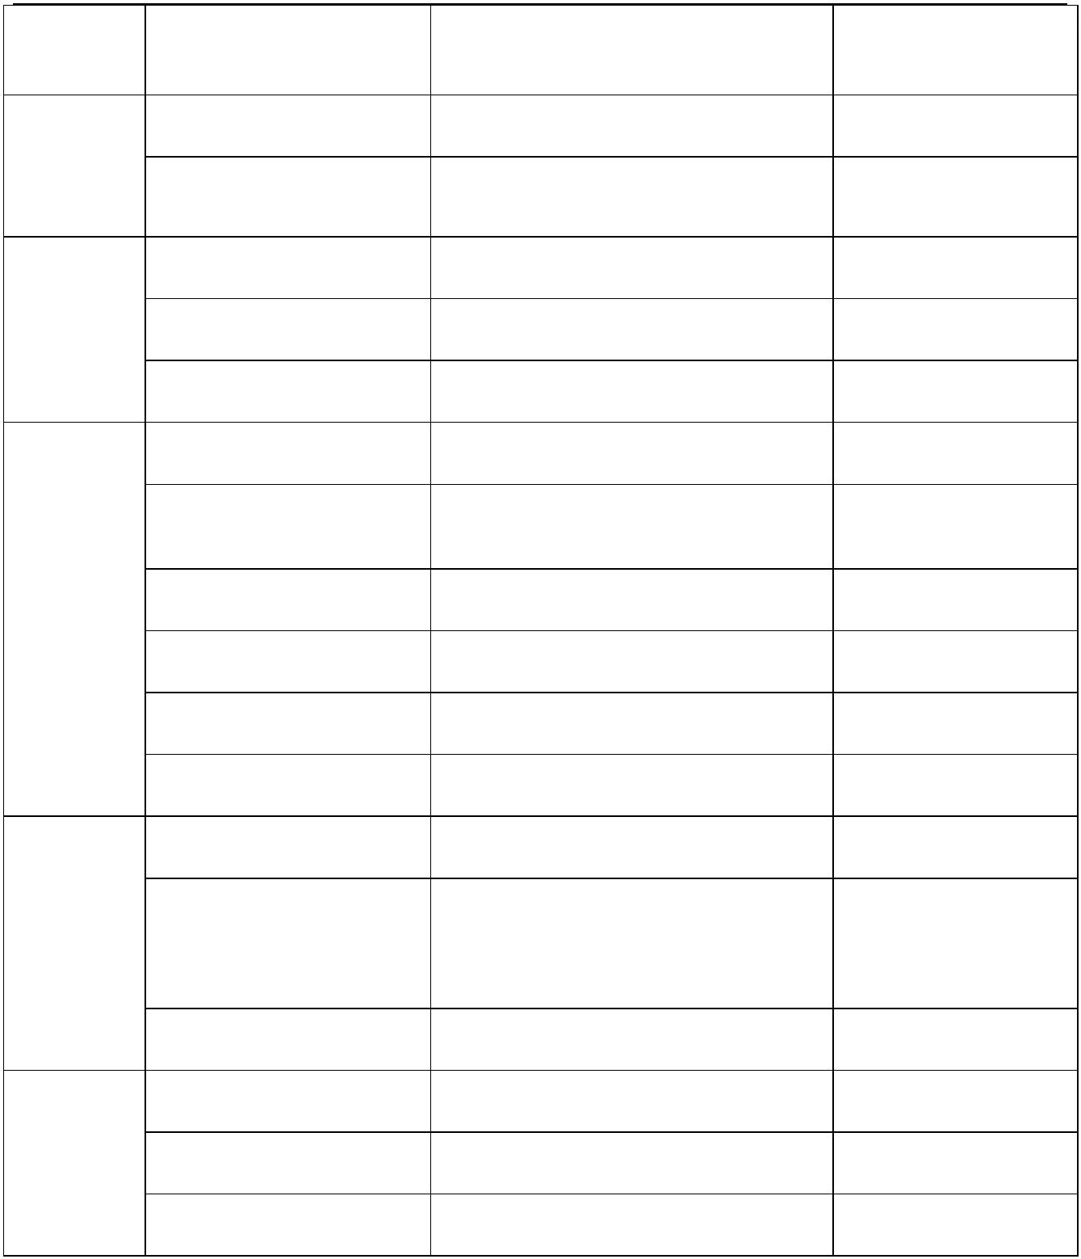

5.11FFG-150 Type
Price list
No
Product name
Unit price(USD)
Quantity
1set
price (USD)
220000
1
2
3
4
5
Fermentation body
Material lifting device
Ladder
2
20000
750
Deodorizing device
PVC /PP pipes
4
pieces
3pieces 40"HC
piece 40"OT

6
Port Fee (Qingdao)
3000
1
7
Total price
Product data
Product Model
Tank volume
Tank diameter
Tank height
11FFG-150
About 150m³
6500mm
5500mm
Ceiling height
Weight
8700mm
45 tons
Installed power
54.6kw (Including auxiliary heating equipment)
Fermentation machine list 11FFG-150
Part
Name
Specifications
Manufacturer
Outside wall material and
thickness
Q235,4.5mm
Green World
Internal bottom plate
material and thickness
Internal roof plate material
and thickness
SUS304, 2mm
Green World
Tank
body
SUS304 1.5mm
Green World
Green World
Thermal insulation material
Polyurethane ≥60mm
1
0
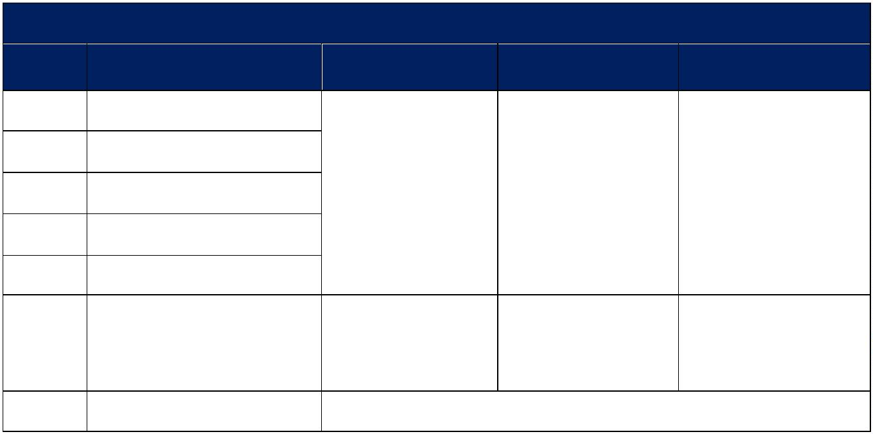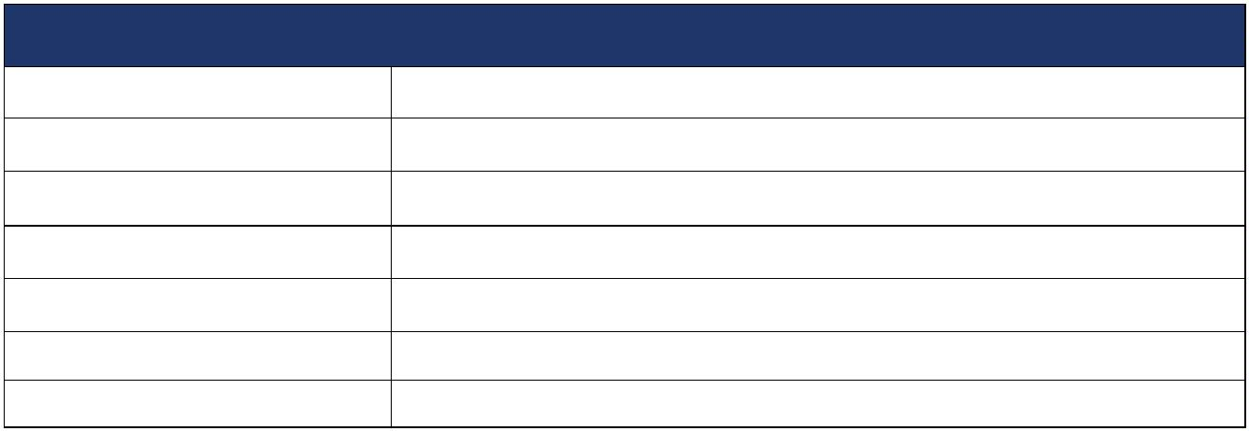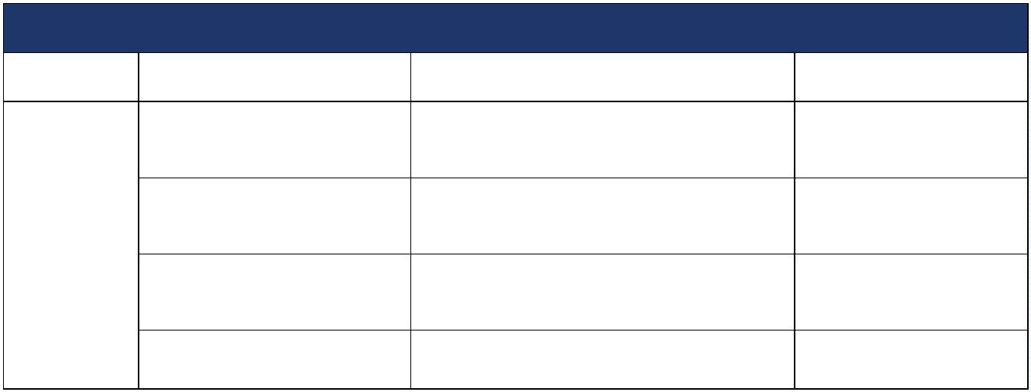

and thickness（mm）
Except the main bone, the other parts in
Stirring blades
Bucket motor
Green World
contact with material are SUS304
2.2KW
Taiwan CPG
Green World
Lifting
bucket
Lifting bucket material and
thickness
Internal surface SUS304 1.5mm
Exhaust fan
Upper blower
Cast aluminum
Siemens motor
HITACHI JAPAN
HITACHI JAPAN
Green World
Ventilati
on
system
High pressure blower
High pressure blower
motor：Siemens Bader
Bottom blower
Hydraulic station power
American PARKER or German
TRELLEBORG
Hydraulic cylinder seal ring
World famous Brand
Drive
system
Hydraulic pump
Pin rotation
Germany Rexroth
Graphite copper sleeve
Germany Brand
Green World
Shaft sealing ring
Lubricating
Imported from Japan
Imported from Japan
Green World
Automatic centralized lubrication
Double door waterproof，380V,50Hz
Electrical box
Green World
Control
system
Electrical elements
Schneider, Omron，PLC Siemens
World famous Brand
Limit switch
Exhaust pipe
Omron
PVC/PP
Omron
Green World
Green World
Green World
Deodoriz
ing
device
Deodorization process
Deodorization tank material
Water washing + adsorption
SUS304
11
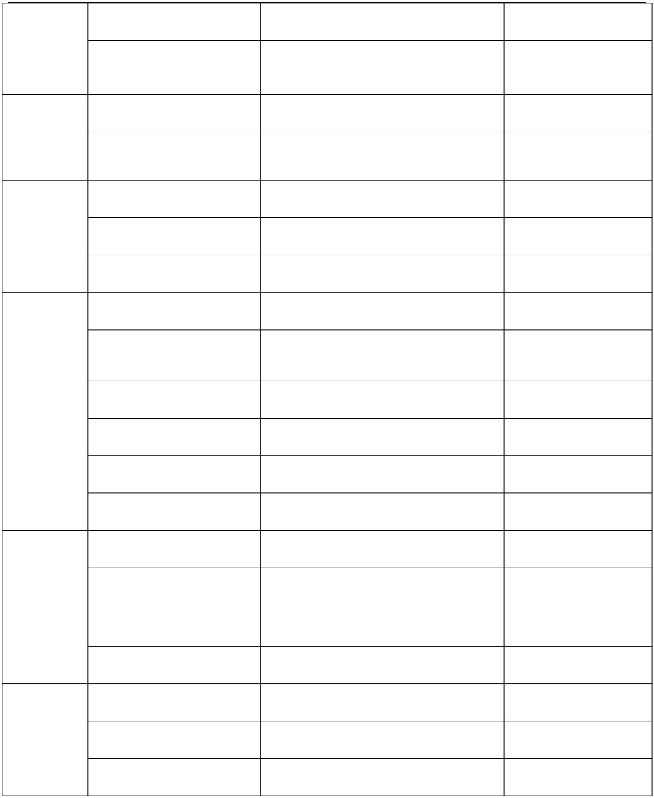

6. 11FFG-200 Type
Price list
No
Product name
Unit price (USD)
Quantity
1set
price (USD)
240000
1
2
3
4
5
Fermentation body
Material lifting device
Ladder
2
40000
Deodorizing device
PVC /PP pipes
4pieces
2
pieces 40"HC
6
Port Fee (Qingdao)
750
3000
1
1
piece 40"OT
piece 40"FR
7
Total price
Product data
Product Model
Tank volume
Tank diameter
Tank height
Weight
11FFG-200
About 200m³
7600mm
6000mm
54.8 tons
Installed power
69.3kw(Including auxiliary heating equipment)
Fermentation machine configuration 11FFG-200
Part
Name
Specifications
Manufacturer
Outside wall material and
thickness
Q235,4.5mm
Green World
Tank
body
Internal bottom plate
material and thickness
Internal roof plate material
and thickness
SUS304, 2mm
SUS304 1.5mm
Green World
Green World
1
2
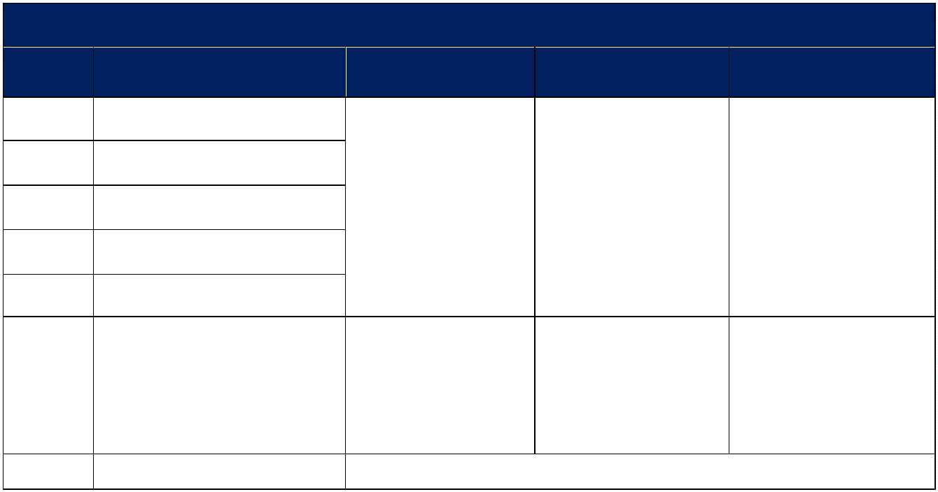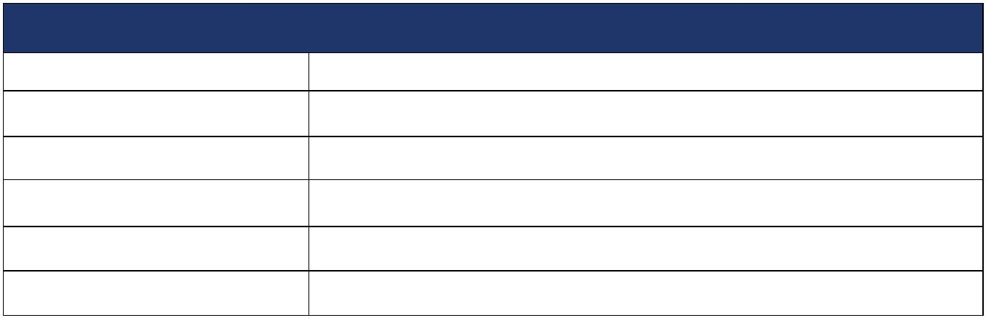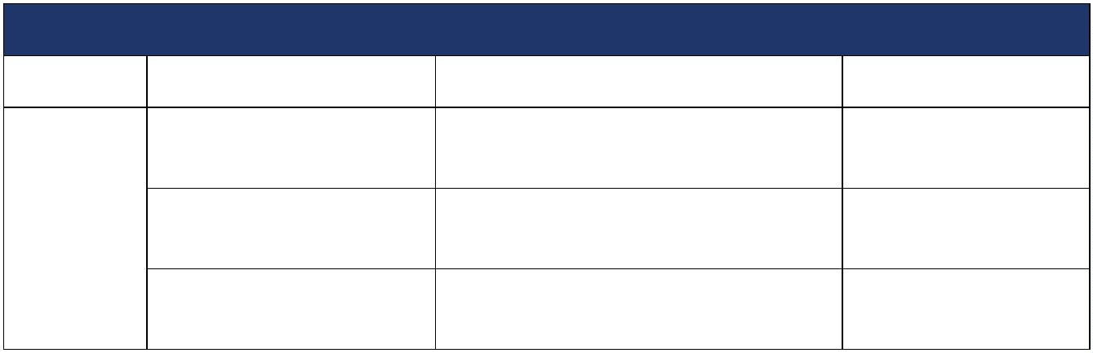

Thermal insulation material
and thickness
Polyurethane ≥60mm
Green World
Green World
Except the main bone, the other parts in
contact with material are SUS304
Stirring blades
bucket lifting motor
2.2KW
Taiwan CPG
Green World
Lifting
bucket
Lifting bucket material and
thickness
Internal surface SUS304 1.5mm
Exhaust fan
Upper blower
Cast aluminum
High pressure blower
High pressure blower
motor：Siemens Bader/ABB
Siemens motor
HITACHI JAPAN
HITACHI JAPAN
Green World
Ventilatio
n system
Bottom blowers
Hydraulic station power
Hydraulic cylinder sealing
ring
American PARKER or German
TRELLEBORG
World famous Brand
Drive
Hydraulic pump
Shaft sealing ring
Pin rotation
Germany Rexroth
Imported from Japan
Germany Brand
Imported from Japan
Green World
system
Graphite copper sleeve
Lubrication
Automatic centralized lubrication
Double-door waterproof，380V/50Hz
Schneider, Omron, Siemens
Green World
Electrical box
Electrical elements
Green World
control
system
World famous Brand
Limit switch
Omron
Omron
Exhaust pipe
PVC/PP
Water washing + adsorption
SUS304
Green World
Green World
Green World
Deodorizi
ng device
Deodorization process
Deodorization tank material
1
3
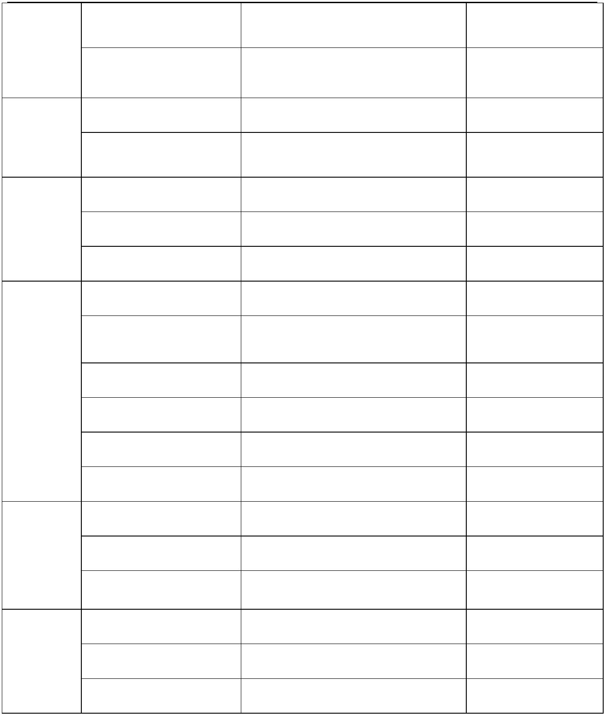

Part two：Company profit
Our company is located in Qingdao, with over 30 years of experience in producing
fermentation equipment and have mature and stable technology
The main partners are:
New Hope Group, Twin Group, Haida Group, Paragon Poultry Company, QL company, etc.
Foreign customers are distributed in more than 30 countries, including Japan, South Korea,
Russia, Thailand, the Philippines, Vietnam, Malaysia, Bangladesh, and Nigeria
Part three：Product configurations photos
1
. Tank body - all inner walls are made of 304 stainless steel material
2
. Stirring blades-The contact area with feces is using 304 stainless steels
1
4
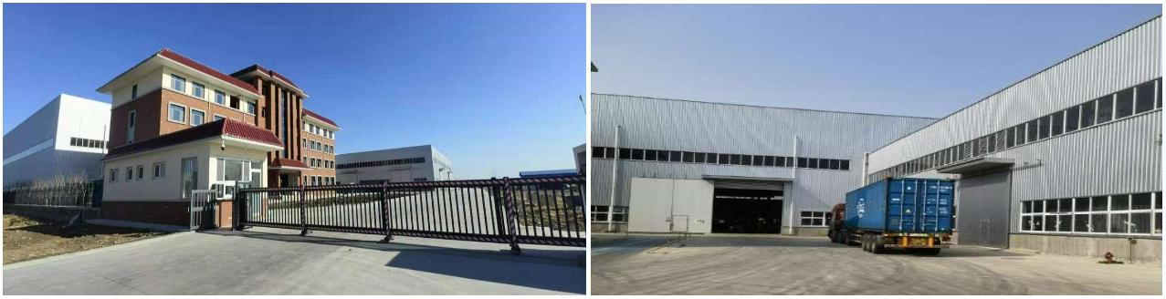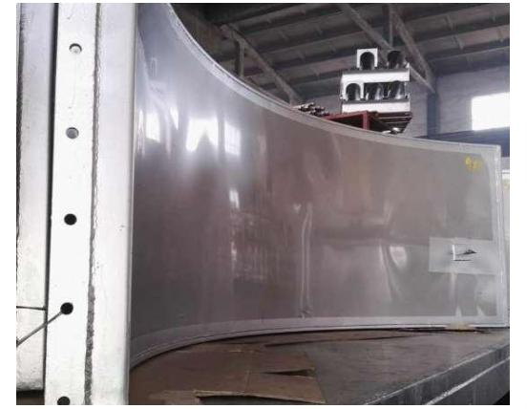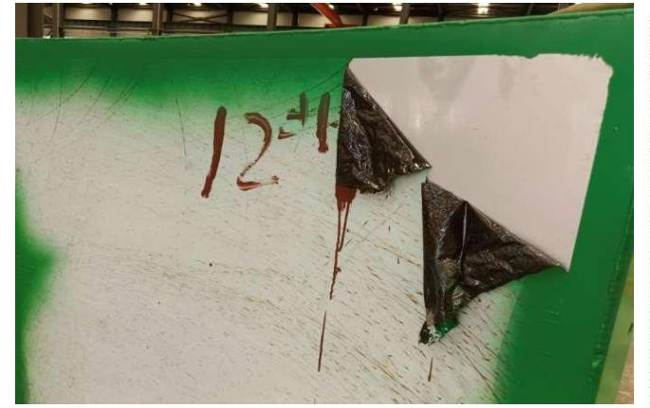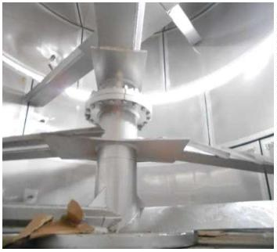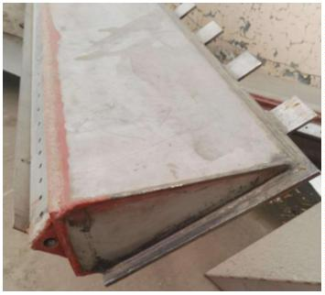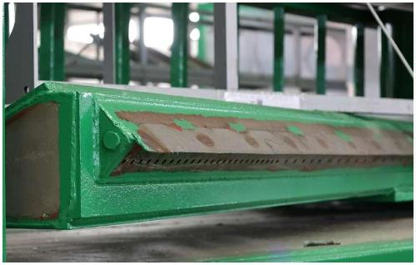

3
.Blower-Using Japanese brand Hitachi blower
4
. Hydraulic Station
The hydraulic pump of the hydraulic station is from Japan Daikin or Germany Rexroth
5
. Main shaft sealing and lubrication device
Main shaft sealing：sealing rings are imported from Japan / American PARKER /German
TRELLEBORG
lubrication device：Centralized lubrication, graphite copper sleeve is used at the rotating
parts.
1
5
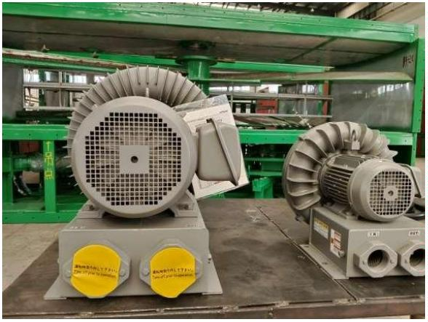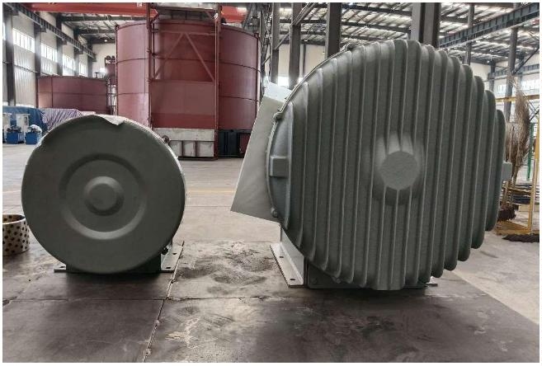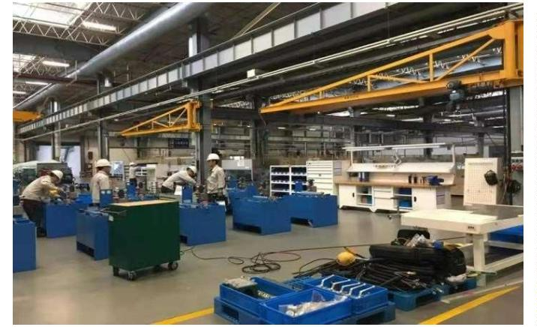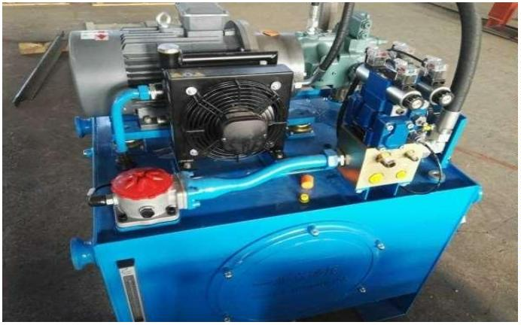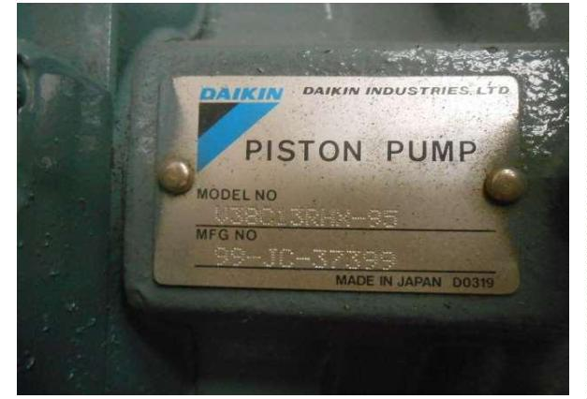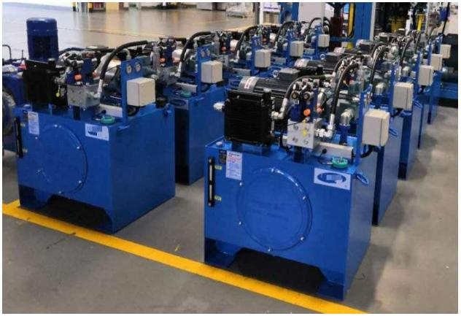

6
. Control system
Line numbers, clear labeling, wiring scale in the control box, main electrical
components :Omron, Schneider, PLC Siemens
1
6
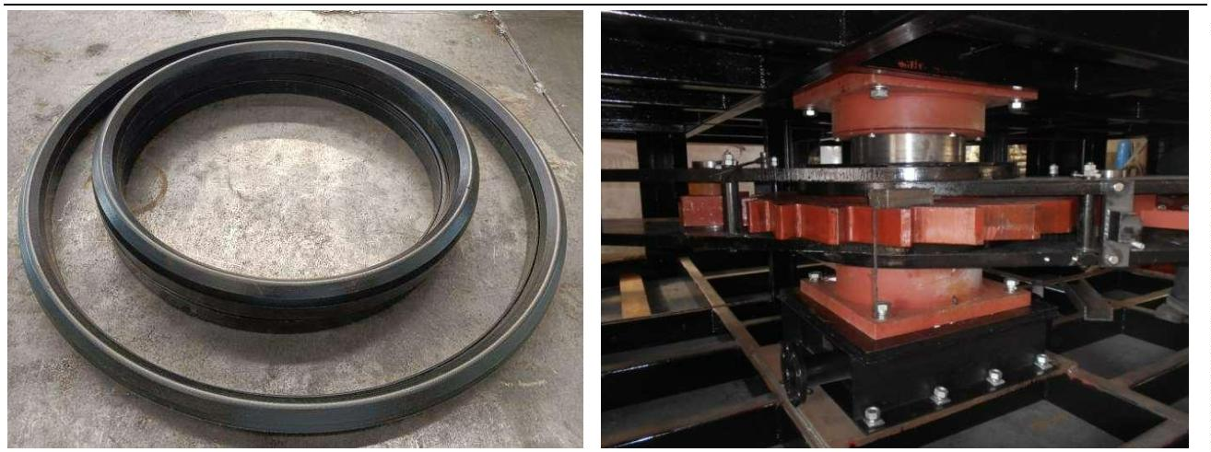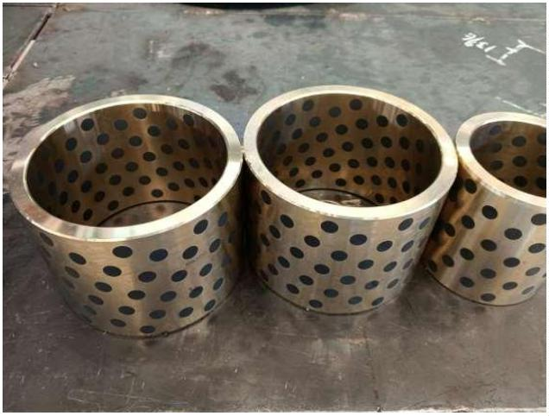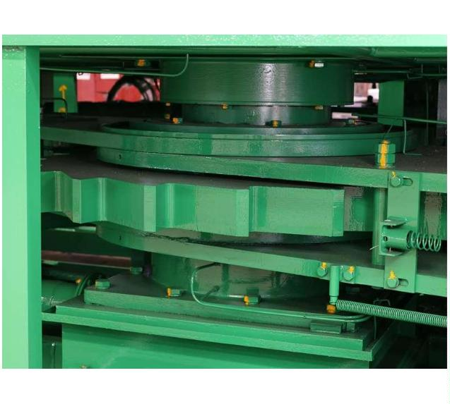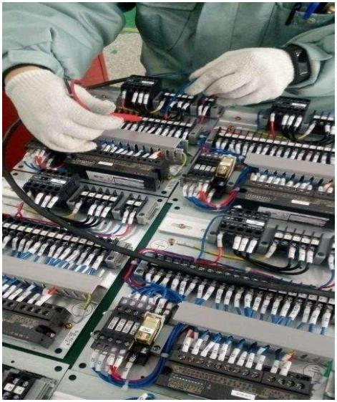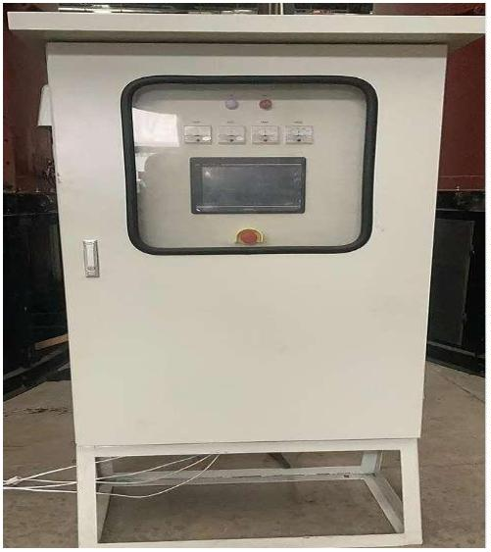

Part four：Production process
1
. Advanced production equipment
Our factory has many advanced production equipment such as laser cutting machine, flame
cutting machine, robot welding, etc.
2
. Production and processing
drive arm production
1
7
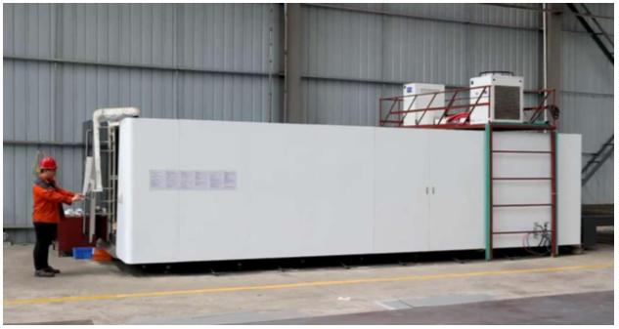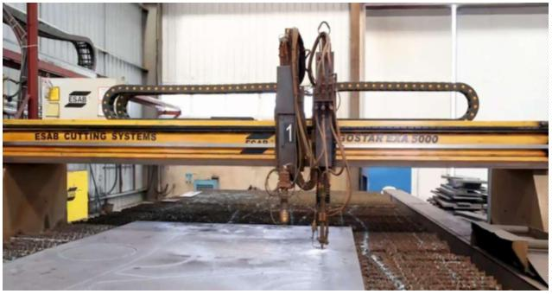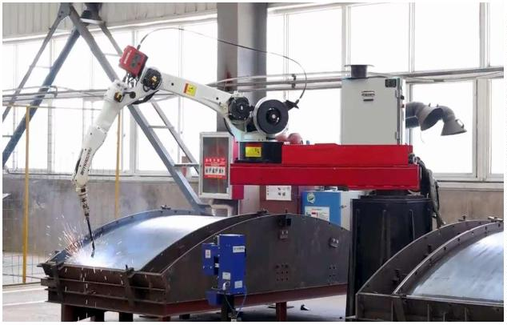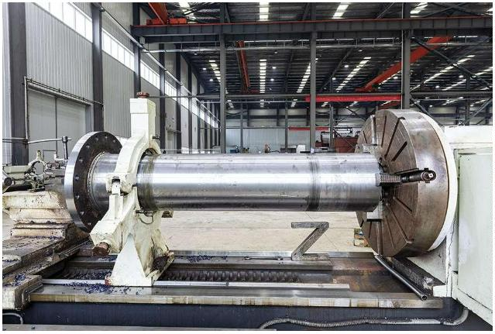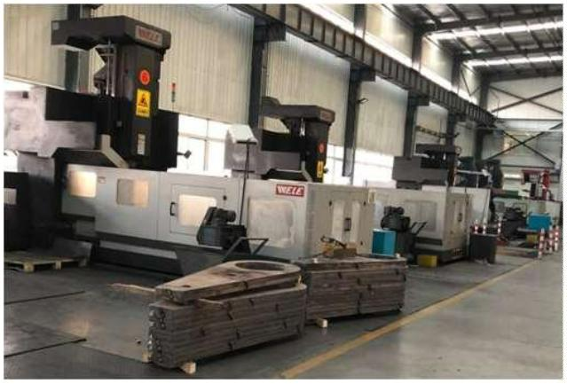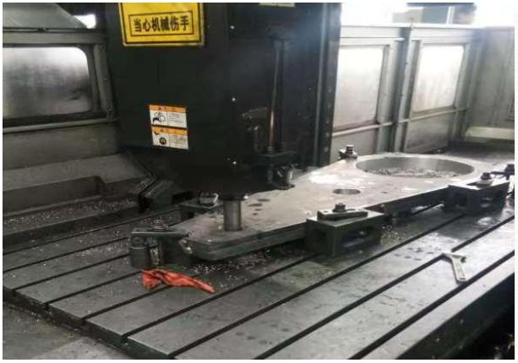

Spindle, ratchet, stirring wing using robot welding
Major component welding
1
8
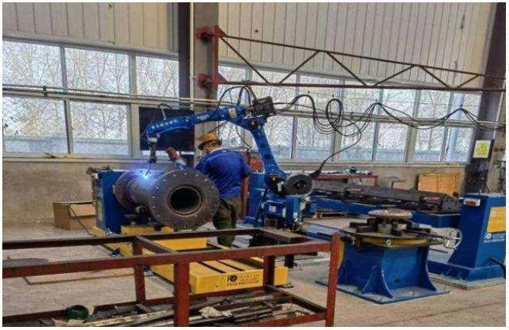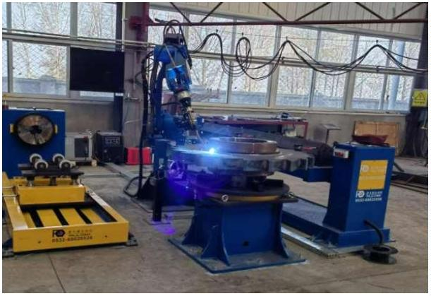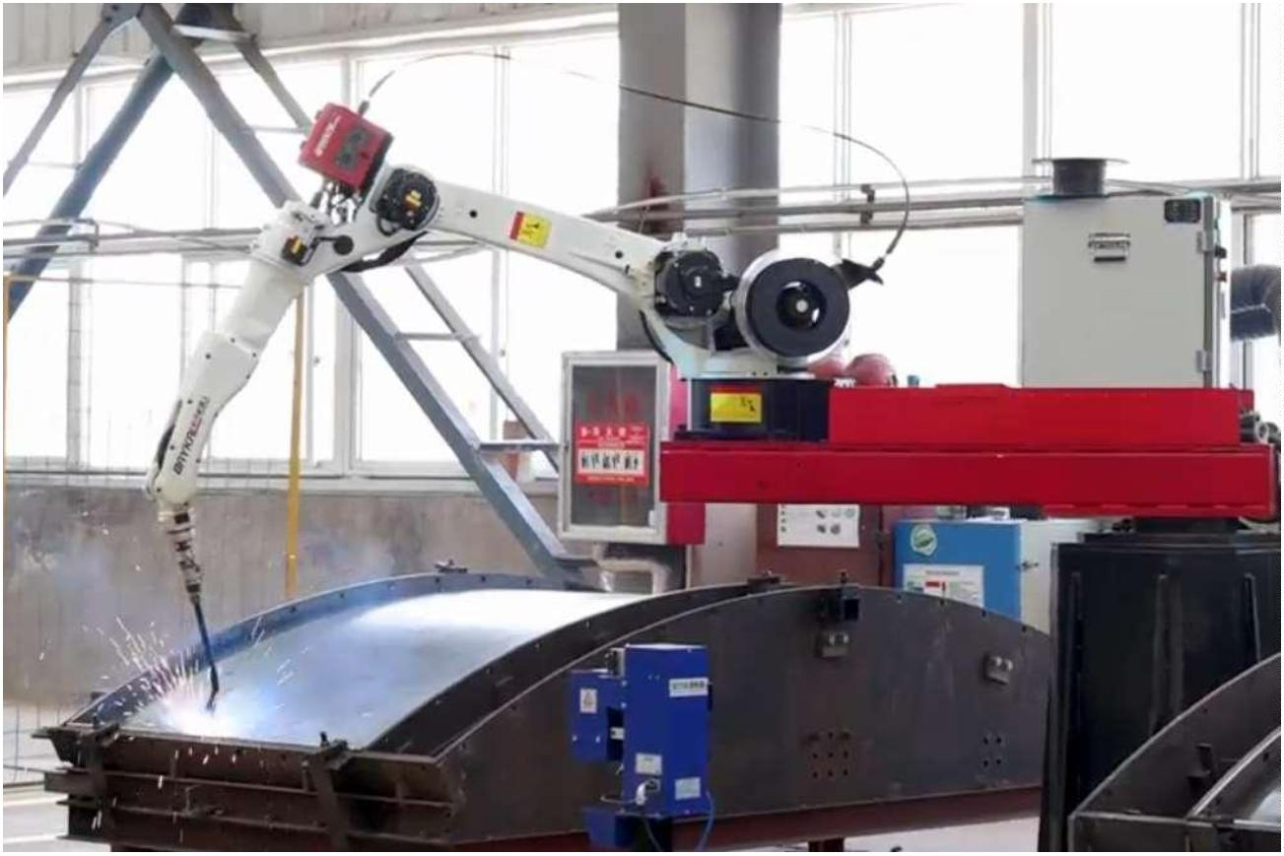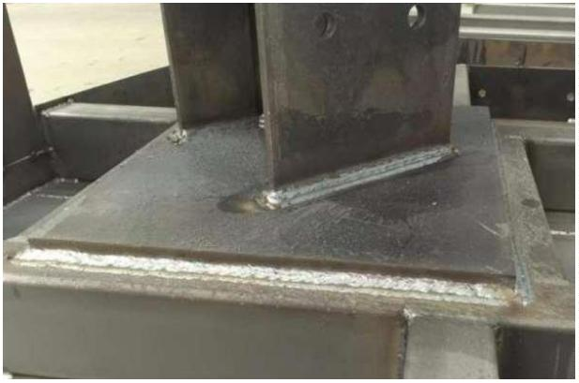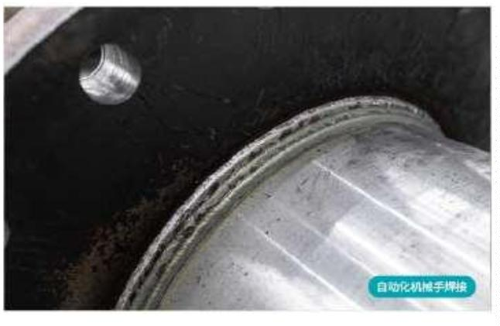

3
. Assembly and debugging
Equipment factory pre-assembly, trial operation
1
9
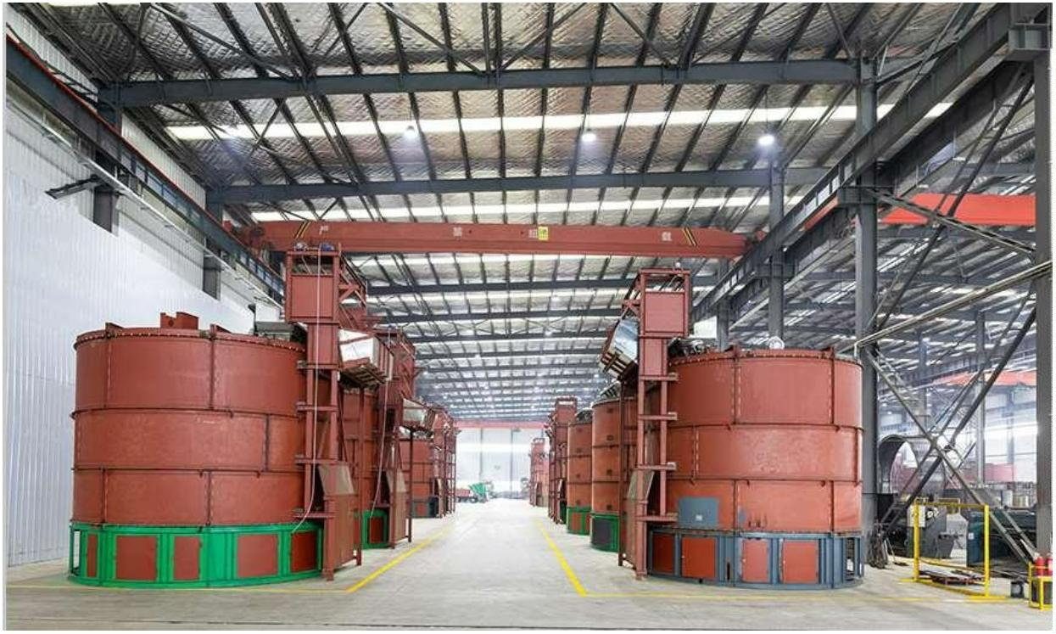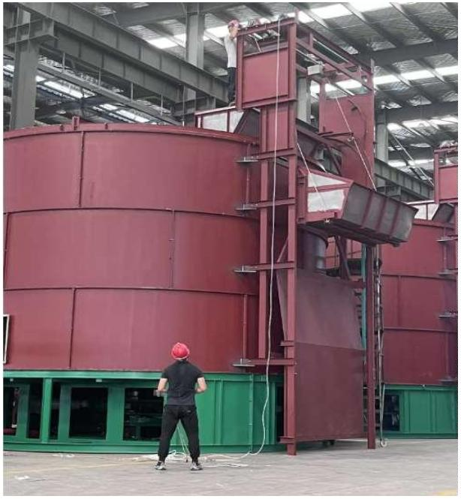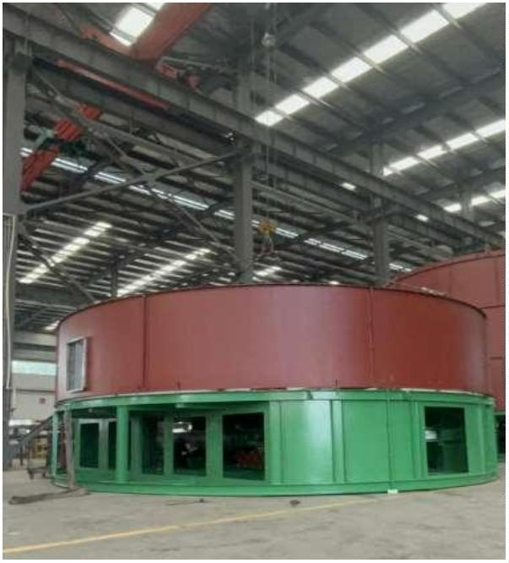

Part five：Project case
The product is widely used in the treatment of livestock and poultry manure, kitchen
waste, river sludge, Carcass of livestock and poultry, mushroom residue, municipal
sludge, crop straw
Under sufficient oxygen supply conditions, organic matter is degraded and stabilized through
the action of microorganisms, achieving harmless and resourceful processes.
2
0
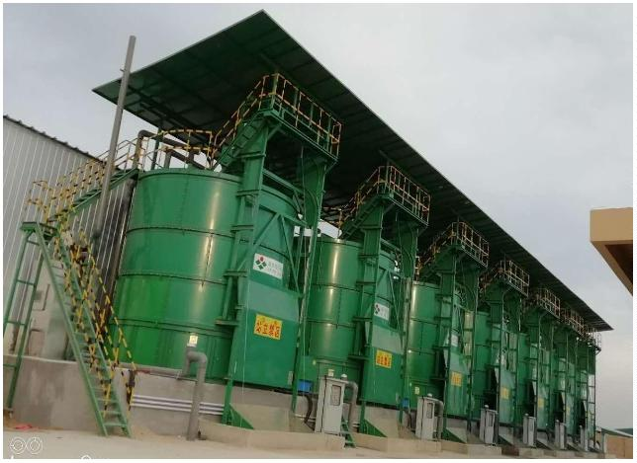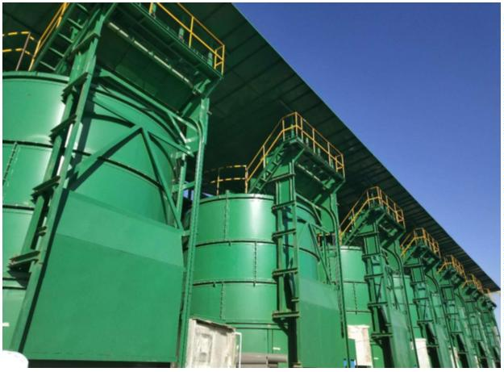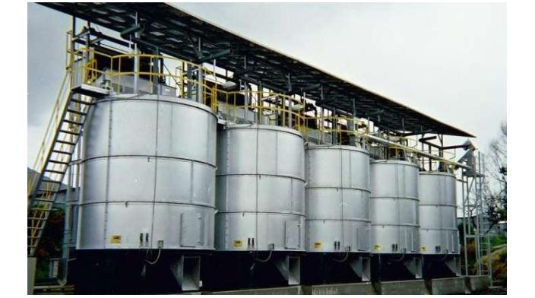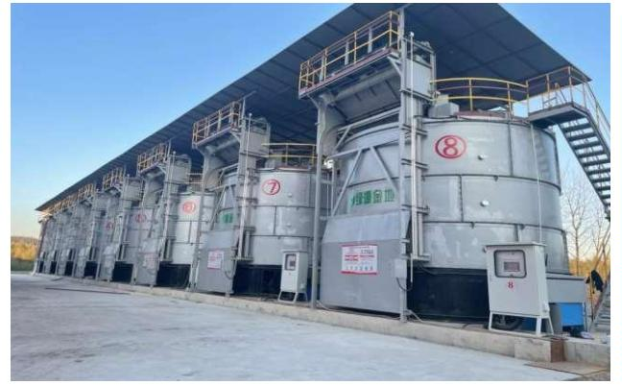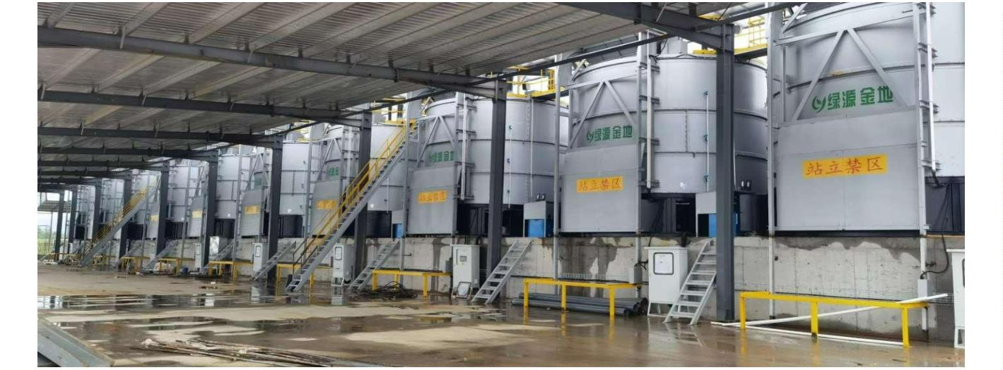

Finished product
2
1
