THERMAL DECOMPOSITION PLANT

TDP 2000F

1. About

The Thermal Decomposition Plant (TDP) is a set of equipment that provides thermal destruction (decomposition into low molecular weight components without oxygen) of oily waste with the production of hydrocarbon gas, liquid hydrocarbons (liquid fuel) and dry residue (carbo or technical soil). Technological equipment is controlled from the operator’s control panel. To control the technological parameters of the equipment, control-measuring devices and automated process control system (APCS) are installed.

Composition and parameters of equipment Installations can be specified in the design process.

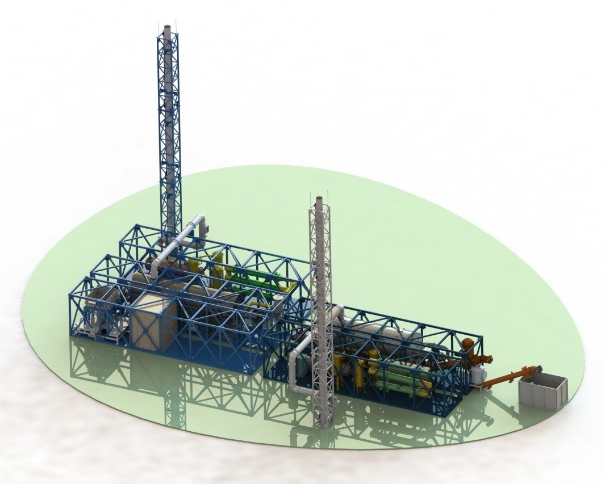
General view of the technological line based on TDP 2000F (layout example)

2. Specifications

The Table shows the specifications of the TDP.
Parameter name | TDP 2000F
Productivity on the processed raw materials (Waste), kg / h | Up to 2000 (Note 1)
Operation mode | Continuous
Type of additional (starting) fuel | Boiler (stove) fuel  Diesel fuel  Pyrolysis gas  Natural gas
Type of main fuel | Pyrolysis gas  Boiler (stove) fuel
Main fuel consumption  Pyrolysis gas, m³/h  Boiler (stove) fuel, l/h | Up to 150*  60-80
Power consumption of the main process equipment, kW/h | Up to 50
Number of staffs, people | 2 / shift
The minimum area to accommodate the main technological equipment, m² | 375
Power supply, V | 380
Current frequency, Hz | 3Р, 50
To accommodate one pr oduction line, a platform with minimum dimensions of 25 (m) x 15 (m) is required.
* The value is specified

Note 1.
Due to the high calorific value of polyethylene, the TDP 2000F unit can process 1500-1700 kg/h of plastic, polyethylene.
From a ton of plastic, polyethylene you will be able to receive: 700-900 liters of liquid hydrocarbons.
From a ton of tires, you will be able to receive up to: 400-600 liters of liquid hydrocarbons.
From 1000 liters of processed used oil, you will be able to receive up to 900 liters of liquid hydrocarbons.

The TDP 2000F unit can process 2000 kg/h of tires, 1500 kg/h of plastic or polyethylene, up to 4000 kg/h of used oil.
Liquid hydrocarbons (synthetic fuel), of which 60-80 l / h will go to the operation of the installation, the remainder of the fuel can be exploited as a commercial product.

TDP equipment can process the following wastes:
- Electrical
- Electronic scrap (phones, boards, monitors, televisions, computers, used printer cartridges, etc.),
- Batteries
- Solid state batteries
- Compact discs, CD discs, VHS tapes, audio storage devices - bobbins, floppy disks
- Telephone cable, extension cords, electrical cable
- Medical waste (syringes, dropper systems, gloves, Personal protective equipment (PPE) (COVID-19))
- Medicines
- Paraffin wax
- Waste from paint and varnish production
- Coals, coal tar
- Plastic, polyethylene, film
- Waste rubber products (car tires, rubber insulators, conveyor belts, other rubber products),
- Insulating materials,
- Expanded polystyrene, styrofoam
- Acid tars, oil refinery waste
- Oil sludge
- Drill cuttings
- Rubber personal protective equipment, including employees of nuclear power plants (gas masks, overalls, boots, gloves),
- Technical oils
- Oily, oily scale in metallurgical plants
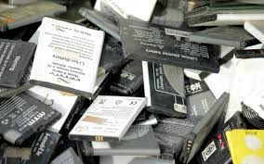
- Water contaminated with oil and oil products
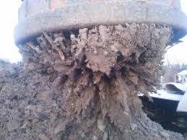
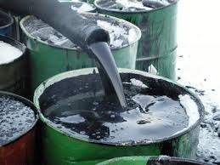

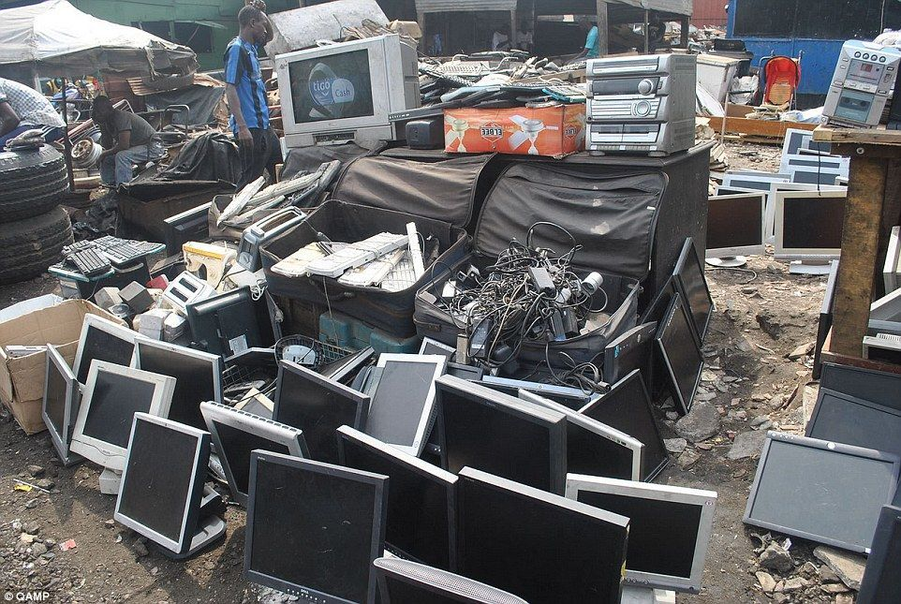
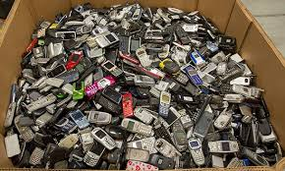
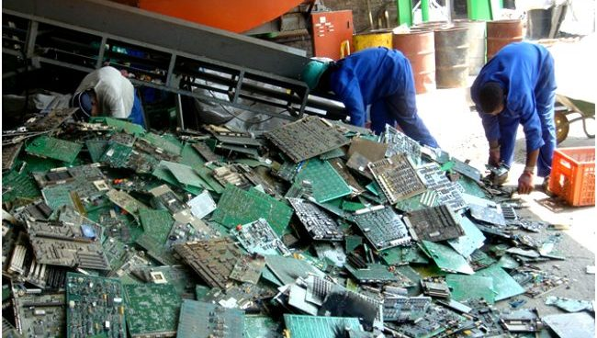

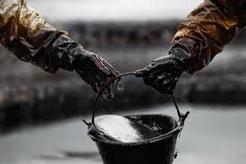

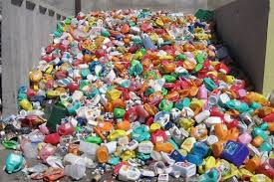
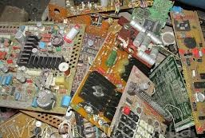

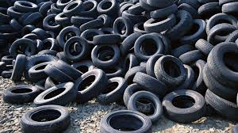

Estimated composition of pyrolysis gas:
The component name | Measurement procedure | Method of analysis | Measured value, units of measurement | The result of the measurement, ± the boundaries of the absolute error
Methane | [1] | Gas chromatographic | Molar fraction, % | 24,5 ± 2,5
Ethane | [1] | Gas chromatographic | Molar fraction, % | 3,2 ± 0,3
Ethylene | [1] | Gas chromatographic | Molar fraction, % | 5,2 ± 0,5
Propane | [1] | Gas chromatographic | Molar fraction, % | 0,52 ± 0,05
Propylene | [1] | Gas chromatographic | Molar fraction, % | 2,85 ± 0,29
Hydrocarbons C4 | [1] | Gas chromatographic | Molar fraction, % | 0,101 ± 0,010
Neopentane | [1] | Gas chromatographic | Molar fraction, % | 0,121 ± 0,012
Isopentane | [1] | Gas chromatographic | Molar fraction, % | 0,055 ± 0,005
n-Pentane | [1] | Gas chromatographic | Molar fraction, % | 0,128 ± 0,013
Hydrocarbons C6 | [1] | Gas chromatographic | Molar fraction, % | 0,102 ± 0,010
Helium | [1] | Gas chromatographic | Molar fraction, % | 0,00177 ± 0,00018
Hydrogen | [1] | Gas chromatographic | Molar fraction, % | 8,5 ± 0,9
Methanol | [1] | Gas chromatographic | Molar fraction, % | 0,229 ± 0,023
Hydrogen sulphide | [1] | Gas chromatographic | Molar fraction, % | 0,042 ± 0,0040
Carbonyl sulfide | [1] | Gas chromatographic | Molar fraction, % | 0,0110 ± 0,0011
Methylmercaptan | [1] | Gas chromatographic | Molar fraction, % | 0,0172 ± 0,0017
Ethyl mercaptan | [1] | Gas chromatographic | Molar fraction, % | 0,000118 ± 0,000012
Dimethyl sulfide | [1] | Gas chromatographic | Molar fraction, % | 0,00075 ± 0,00008
Disulfide | [1] | Gas chromatographic | Molar fraction, % | 0,000116 ± 0,000012
Benzene | [1] | Gas chromatographic | Molar fraction, % | 0,163 ± 0,016
Toluene | [1] | Gas chromatographic | Molar fraction, % | 0,101 ± 0,010
Ethylbenzene | [1] | Gas chromatographic | Molar fraction, % | 0,0076 ± 0,0008
m -, p-Xylene | [1] | Gas chromatographic | Molar fraction, % | 0,0159 ± 0,0016
o-Xylene | [1] | Gas chromatographic | Molar fraction, % | 0,0056 ± 0,0006
Oxygen | [1] | Gas chromatographic | Molar fraction, % | 0,48 ± 0,05
Nitrogen | [1] | Gas chromatographic | Molar fraction, % | 1,76 ± 0,18
Carbon dioxide | [1] | Gas chromatographic | Molar fraction, % | 23,7 ± 2,4
Carbon monoxide | [1] | Gas chromatographic | Molar fraction, % | 28,1 ± 2,8

Physical and chemical indicator | Unit of measurement | Estimated value of the indicator
The highest molar heat of combustion | kJ/mol | 546
The lower molar heat of combustion | kJ/mol | 505
The highest mass heat of combustion | MJ/kg | 19,8
The lower mass heat of combustion | MJ/kg | 18,3
The highest volumetric heat of combustion | MJ/m³ | 22,76
The lower volumetric heat of combustion | MJ/m³ | 21,06
Relative density |  | 0,956
Absolute density | kg/m³ | 1,15
The highest Wobbe index | MJ/m³ | 23,3
The lower Wobbe index | MJ/m³ | 21,5

3. System and principal of operation of TDP 2000F.
Main technological equipment
- Waste loading / unloading system
- Pyrolysis oven unit:
• Pyrolysis chamber
• Burner
• Combination burner kit
- Condensation unit:
• Pyrolysis gas filter
• Condenser heat exchanger
• Coolant Circulation Pump
• Air cooler
• Expansion tank
• Gas-liquid separator
- Mist eliminator
- Gas dryer
- Tank of finished products
- Liquid fuel pump
- Compressor for air supply, with receiver
- Gas igniter
- Smoke exhauster
- Chimney
- Nitrogen ramp consisting of 4 cylinders with pressure regulator

4. Process Description

Prepared waste is accumulated in a storage container. Then fed with an automated screw from the feeder to the thermochemical reactor. When heated without oxygen, their thermal decomposition occurs (destruction). The operating temperature depends on the type of waste. Heating to the operating temperature of 360-650 °C in the thermochemical reactor is carried out through its walls with burner devices installed in the furnace.
The burner can operate on syngas or liquid hydrocarbons, which are generated after waste recovery.
The vapor-gas mixture from the thermochemical reactor enters the syngas filter to condense the heavy fraction. Condensed fractions are automatically fed to the reactor for recovery.
After the syngas filter, the vapor-gas mixture enters the heat exchanger. In the heat exchanger, the vapor-gas mixture is cooled by coolant circulating in the system.
Circulation and cooling of the coolant produced by the pump through the air cooler. To compensate for changes in the volume of coolant during heating and cooling, an expansion tank is installed on the pump suction line.
Products from the heat exchanger enter the gas-liquid separator, where the separation of the liquid and gaseous fractions takes place. The liquid fraction through the lower pipe is discharged into the storage tank, and the syngas enters the gas-drying column. After the gas-drying column, the syngas enters the hydraulic lock.
The cleaned gas is fed to the gas receiver for storage.
This syngas can be used to generate hydrogen, generate electricity or to heat a thermochemical reactor.
Liquid fuel from the storage tank is pumped periodically by the pump into the fuel tank or to the finished product storage. In this case, water separation is carried out using a separator and a filter system.
Unloading of technical soil or recovered carbon black from the reactor is performed continuously using an automated screw.
In case of emergency situations, to prevent air from leaking into the reactor, automatic supply of nitrogen from the receiver of the nitrogen generator is provided.

Automated process control system
To maintain the optimum operating mode of the complex, an automated process control system based on a Siemens, Schneider Electric, a touch-sensitive control panel and a set of instrumentation is provided.

